Instructions : Choose the letter of the best answer. In all cases, NOTA means “none of these answers”.

1)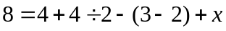, find x.

A. 3 B. 4 C. 7 D. 8 E. NOTA

2) Calculate 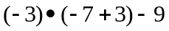.

A. 15 B. 3 C. -12 D. -21 E. NOTA

3) Solve for y in the following equation: 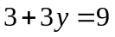

A. 1 B. 2 C. 3 D. 4 E. NOTA

4) Given the equation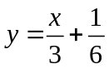, what is the value of x when y =.

A. 0 B. 1 C. 2 D. 3 E. NOTA

5) The are of a triangle is equal to ½ times the base times the height of the triangle (A = ½ bh). Find the area of the following triangle:
4
3
A. 5 B. 6 C. 12 D. 24 E. NOTA

6) Evaluate 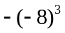

A. 24 B. -24 C. 512 D. -512 E. NOTA

7) Using the formula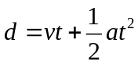, 5 for velocity (v), 4 for acceleration (a), and 3 for time (t), find d.

A. 15 B. 33 C. 87 D. 558 E. NOTA

8) Evaluate 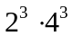
A. 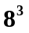 B. 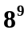 C. 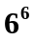 D. 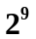 E. NOTA

9) Write the product of 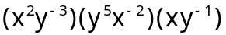 in terms of x and y

A. 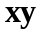 B. C. 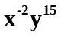 D. 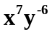 E.NOTA

10) Simplify 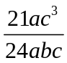
A. 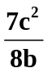 B. 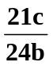 C. 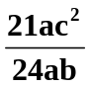 D. 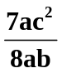 E. NOTA

11) The result of 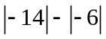

A. -20 B. -8 C. 8 D. 20 E. NOTA

12) Write 0.4 in fraction form in lowest terms.

A. B. C. 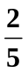 D. 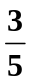 E. NOTA

13) Round 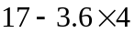 to the nearest integer.

A. 2 B. 2.6 C. 3 D. 54 E.NOTA

14) Find the 11th term in the following arithmetic sequence:
-1, 3, 7, 11, 15 …

A. 16 B. 33 C. 35 D. 39 E. NOTA

15) Divide 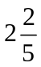 by 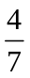

A. 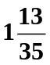 B. 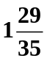 C. 4 D. 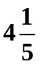 E. NOTA

16) Evaluate 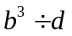 if 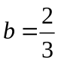, and 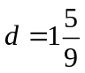

A. 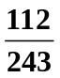 B. 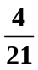 C. 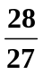 D. 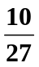 E. NOTA

17) Find the slope of the line that contains the points (-2, 1) and (4, -5)

A. 1 B. -1 C. 2 D. -2 E. NOTA

18) Solve the system of equations 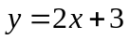 and 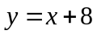. Write the answers as an ordered pair.

A. (2, 3) B. (5, 13) C. (-2, 6) D. (-4, 4) E. NOTA

19) Express as a percent.

A. 3% B. 5% C. 6% D. 60% E. NOTA

20) Choose the equation whose solution is 6.

A. 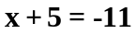 B. 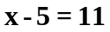 C. 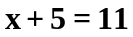 D. 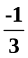 E. NOTA

21) Solve for n when 64n = 24

A. 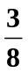 B. 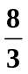 C. -40 D. 40 E. NOTA

22) Find the value of x when 4(2x-1)=0

A. 0 B. C. 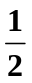 D. 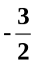 E. NOTA

23) Determine the product of 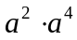

A. 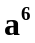 B. 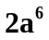 C. 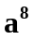 D. 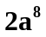 E. NOTA

24) Find the value of 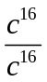, 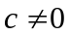

A. 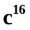 B. 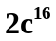 C. 0 D. 1 E. NOTA

25) Simplify 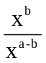

A. 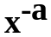 B. 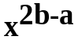 C. 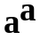 D. E. NOTA

26) Calculate 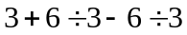

A. 3 B. 0 C. D. -1 E. NOTA

27) Solve 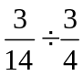

A. 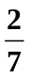 B. 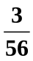 C. 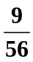 D. 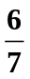 E. NOTA

28) What is the value of 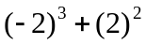 ?

A. 12 B. 4 C. -4 D. -12 E. NOTA

29) Add 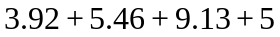.

A. 68.51 B. 23.51 C. 19.01 D. 18.56 E. NOTA

30) Find the next number in the sequence 1, 1, 2, 6, 24, …

A. 24 B. 56 C. 64 D. 120 E. NOTA

